Multivariate Analysis

Data Cleaning and Alignment
Inclusion of multiple explanatory variables presents several technical problems.

- Data gathered from different sources does not have the same degree of credibility.
- Often, different variables/factors are gathered on different intervals (e.g. monthly, quarterly, yearly etc.).
- Data does not span across identical time ranges across variables, specifically, some data may be limited relative to others temporally.
- Variables may have a co-integrating factor, and inclusion of two such variables in such a regression would cause redundancies in the model.

To address 2 and 3, we applied sufficient cut-offs to ensure proper temporal alignment, and linearly interpolated the data from annual/quarterly to monthly.

Exploratory Data Analysis
Regression diagnostics

To assess the need for data transformations, the ACF of the original multivariate data was inspected. Each original series shows a clear unit-root, thus, a simple return transformation was taken for each variable. The resultant ACF plot is shown in figure 5.B.1, for a handful of candidate explanatory variables. This step was necessary, since the use of non-stationary data in a multiple regression analysis can result in spurious regression coefficients and incorrect p-values.

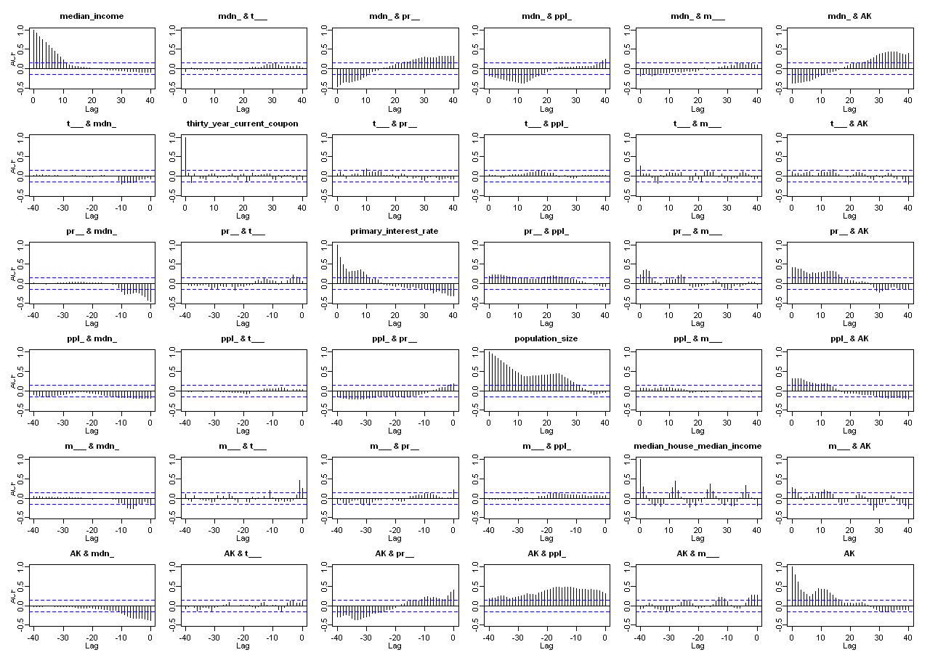
Figure 5.B.1: ACF/CCF of explanatory variables and AK HPI simple returns.

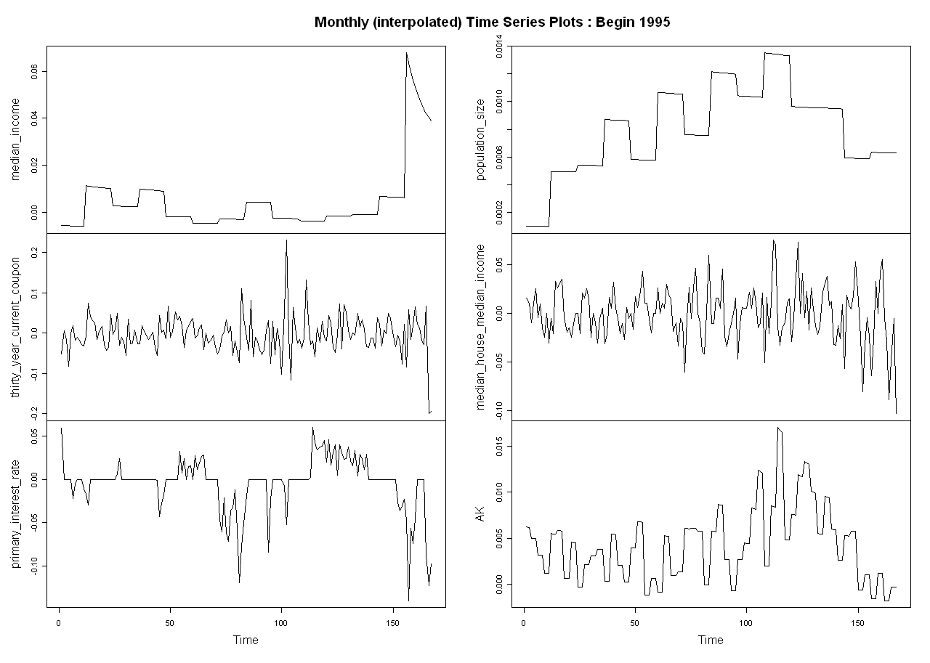
Figure 5.B.2: Time series plot of explanatory variables and AK HPI simple returns.

Modeling Methodology
The modeling of HPI is divided into two phases viz. a) Drift modeling and 2) Volatility modeling. Both the phases are explained in detail as follows:

Phase#1: Drift Modeling
This stage consists of the following steps:

Data preparation

Exploratory data analysis
3) Multiple regression analysis
4) Residual Analysis

Phase#2: Volatility Modeling

1) ARFIMA model fitting
2) Residual analysis

Phase#3: Validation, testing & forecasting

Multiple Linear Regression and Results
After taking appropriate transformations, different sets of explanatory variables were used to attain the highest R² for the multivariate regression. We attained the best regression results with the following set of predictors:

AK ~ median_income +
thirty_year_current_coupon +
primary_interest_rate +
population_size +
median_house_median_income

Estimates
Simple Return | Coeff. | Std.  Error | t-  value | Pr(>|t|)
(Intercept) | 2.30E-03 | 7.60E-04 | 3.09E+00 | 2.30E-03
Median Income | -5.52E-02 | 2.10E-02 | -2.57E+00 | 1.11E-02
Thirty Year Current Coupon | 3.70E-03 | 5.80E-03 | 6.50E-01 | 5.19E-01
Primary Interest Rate | 3.08E-02 | 9.90E-03 | 3.11E+00 | 2.20E-03
Population Size | 2.80E+00 | 8.70E-01 | 3.23E+00 | 1.50E-03
Median House Median Income | 2.29E-02 | 1.00E-02 | 2.26E+00 | 2.49E-02

Table 5.C.1: Regression coefficients and statistics

Analysis of residuals
Validation of assumptions of multiple regression
It’s important to check that the final regression model satisfies the basic premise of a multiple regression framework:
- Homoskedasticity of residuals i.e. the distribution of residuals should be independent of the observations (responses) and they should have a constant variance.
- The final conclusion from the regression model must not be driven by influential outliers in the data. If outliers are detected then the data should be appropriately conditioned to get a robust fit.
- The residuals must be normally distributed.
- There should be no autocorrelation observed in the residuals.

The residual analysis plots (Figure 5.C.1) and the ACF plots (Figure 5.C.2) given below, help us carry out investigations to check if these assumptions hold true for the fitted regression model.
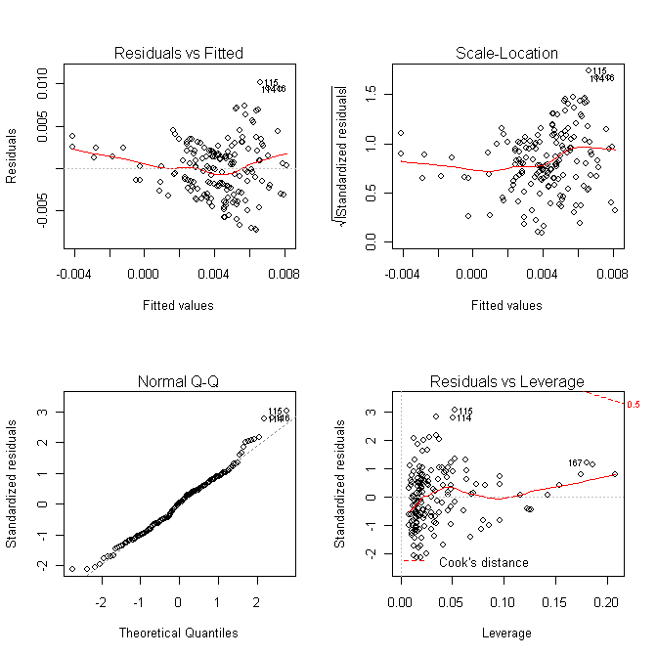
Figure 5.C.1: Residual Analysis

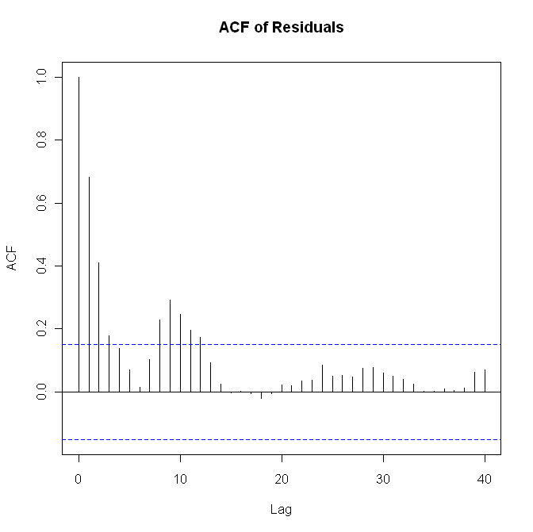 | 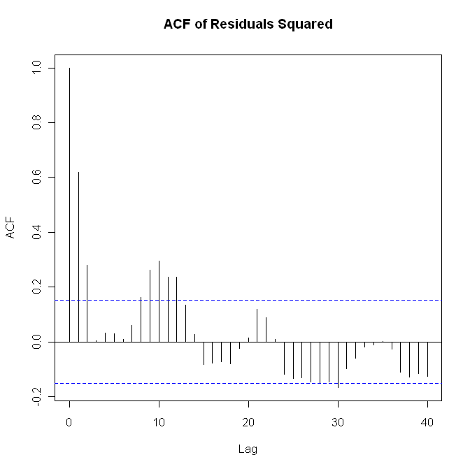
Figure 5.C.2: Residual ACF Plots
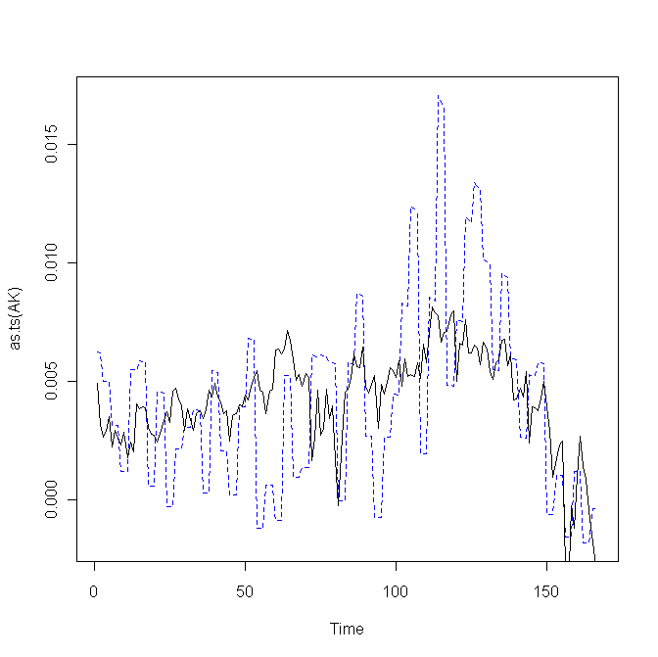
AK vs Fitted : Begin 1995

Figure 5.C.3: Time Series Plots (original vs fitted).
Robust estimates

If any of the assumptions of multiple regression are not met then we have to resort to obtaining robust estimates so that the results of the fitted model are reliable.
The statistical options available, to condition the data, to obtain robust estimates depend on the assumptions that do not hold in the base data. These options are listed as follows:
- Nonlinearity
  - Transformation to linearity
  - Nonlinear regression
- Influential Outliers
  - Robust regression with robust weight functions
- Heteroskedasticity of residuals
  - Regression with Huber/White/Sandwich variance-covariance estimators
- Residual autocorrelation correction
  - Autoregression
  - newey-west regression
- Nonnormality of residuals
  - Quantile regression: qreg y x1 x2
  - Bootstrapping the regression coefficients

